Reg. No. CODE: COREMATH
Ph.D. COURSEWORK EXAMINATION – SEPT/OCT 2023
SUBJECT: MATHEMATICS
CORE PAPER
Time: 03 hours Maximum Marks: 50
Student Name: Mr Praveen

Instructions:
- Question No.1 is compulsory and answer any 4 from questions 2 to 7.
- Statistical tables can be provided.
- Missing values may be considered suitably.

1 | Explain various sampling methods with suitable examples | 10
2a | Find the equilibrium temperature at $x_{1} ,x_{2}$and $x_{3}$ for the heavy wires with endpoints held constant at the given temperatures.  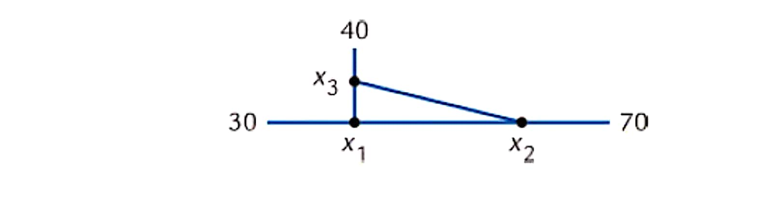 | 5
2b | The components of pure Shearing strain in a sheared material are given in the matrix form $ϵ=\left[\begin{matrix}1 & 1 \\ 1 & -1\end{matrix}\right]$. Here Trace ($ϵ)=0$, given $P=Trace\left(ϵ8\right)and q=Trace\left(ϵ11\right).$ Find the numerical value of ($P+Q)$? | 5
3a | Fit a cubic spline to the following data under the conditions f ‘’(0) = 0 = f ‘’(3) and valid the interval[1, 2]. Hence obtain the estimate of $f(1.5)$  X 0 1 2 3  Y= f(x) 1 4 10 8 | 5
3b | If air resistance is proportional to the square of the instantaneous velocity, then the velocity $v$ of a mass $m$ dropped from a height $h$ is determined from  $\frac{dv}{dt}=g-\frac{kv^{2}}{m}, k>0$.  Let $v\left(0\right)= 0, k=0. 125, m=5 pounds and g=32ft/s^{2}$. Using Runge-Kutta method of fourth order method with $h=1$ to find an approximation to the velocity of the falling mass. | 5
4a | Using the following data, find Fisher’s price and quantity index numbers, construct Fisher’s ideal index and show how it satisfies factor reversal and time reversal tests?  Commodity Price in Rs/unit Number of units  Base year Current year Base year Current year  Water bottle 40 50 160 200  Pencil 20 30 200 240  Chocolate 10 12 80 72  Juice 05 05 40 45 | 5
4b | Fit a straight line trend to the following data on the domestic demand for a motor fuel and estimate demand of 1992.  Year 2002 2003 2004 2005 2006 2007 2008 2009 2010 2011 2012  Average monthly demand million barrels 61 66 72 76 82 90 96 100 103 110 114 | 5
5a | The heights of adult females are normally distributed with mean 160 cm and standard deviation 8 cm.  a) Find the probability that a randomly selected adult female has a height greater than 170 cm.  Any adult female whose height is greater than 170 cm is defined as tall.  An adult female is chosen at random. Given that she is tall,  b) find the probability that she has a height greater than 180 cm.  Half of tall adult females have a height greater than $h$ cm.  c) Find the value of $h.$ | 5
5b | The joint distribution of two varaibles X and Y is as follows  X/Y -4 2 7  1 1/8 1/4 1/8  5 1/4 1/8 1/8  Compute the following  - E(X) and E(Y)  - E(XY)  - $σ_{x}$ and $σ_{y}$  - $COV\left(X,Y\right)$ | 5
6a | The length of life x of certain computers is approximately normally distributed with mean 800 hours and standard deviation 40hrs. If random samples of 30 computers has an average life of 788 hours, test the null hypothesis that $μ=800$ hours against the alternative that $μ≠800$ hours at  - 1%  - 5% | 5
6b | Test for goodness of fit of a Poisson distribution at 0.05 level of significance to the following frequency distribution  Number of patients arriving per hr (x) 0 1 2 3 4 5 6 7 8  Frequency 52 151 130 102 45 12 5 1 2 | 5
7a | Explain population growth and decay models. | 5
7b | A bacterial population B is known to have a rate of growth $α$ to B itself. If between noon and 2pm the population triples, at what time no control being exerted, should B become 100 times what it was at noon? | 5

***********

